AAT LAB 9

Name : Swarangi Kothawade
Div/Roll No. : A-34

LIFO using Stack
#include <iostream>
#include <stack>
using namespace std;

int main() {
stack<int> s;
int n, x;

cout << "Enter number of nodes: ";
cin >> n;

cout << "Enter node values:\n";
for (int i = 0; i < n; i++) {
cin >> x;
s.push(x); // Adds element to the top
}

cout << "LIFO Order (Reverse):\n";
while (!s.empty()) {
cout << s.top() << " "; // Look at the top element
s.pop(); // Remove the top element
}

return 0;
}

OUTPUT
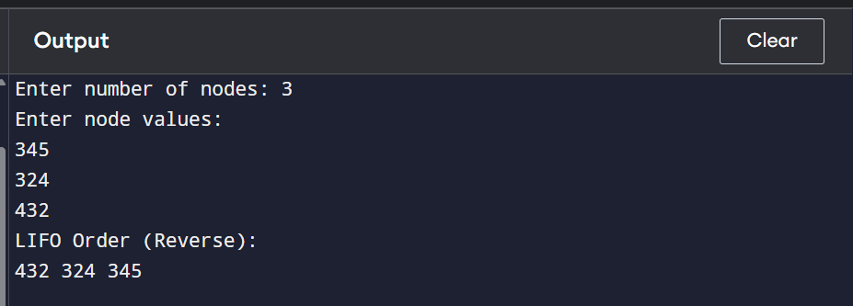

FIFO using Queue
#include <iostream>
#include <queue>
using namespace std;

int main() {
queue<int> q;
int n, x;

cout << "Enter number of nodes: ";
cin >> n;

cout << "Enter node values:\n";
for (int i = 0; i < n; i++) {
cin >> x;
q.push(x); // Adds element to the back of the line
}

cout << "FIFO Order (Same as input):\n";
while (!q.empty()) {
cout << q.front() << " "; // Look at the person at the front
q.pop(); // Remove the person at the front
}

return 0;
}

OUTPUT

